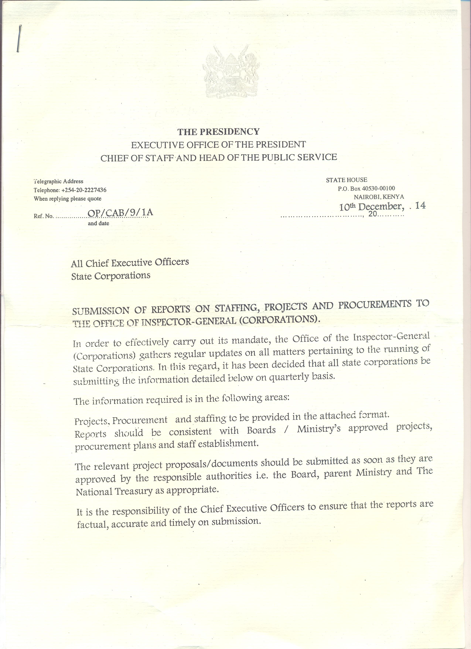

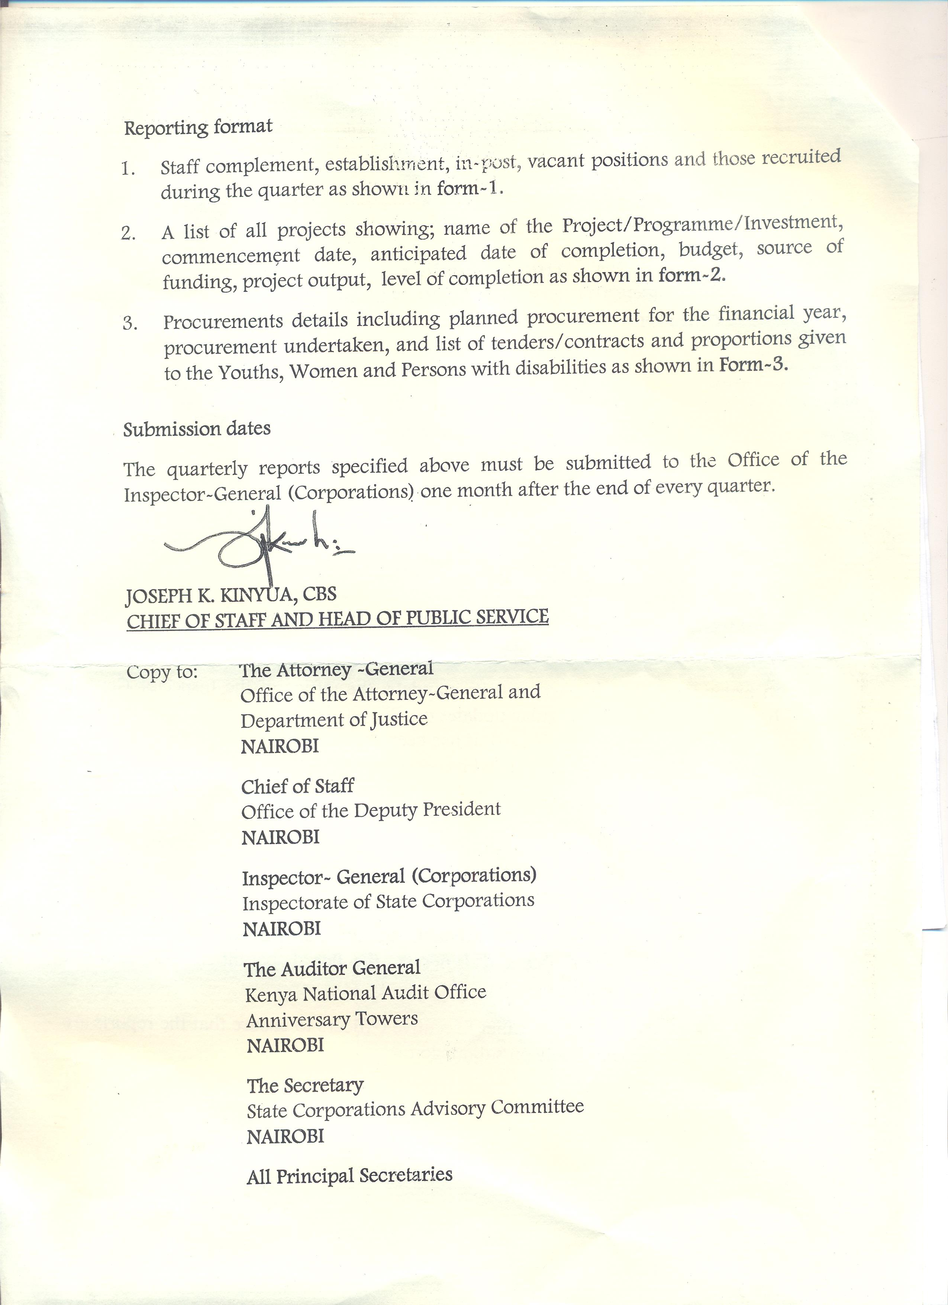

Form 1: Staff Complement
Name of State Corporation :
Reporting Period :

 | Approved Establishment  (No) | In post  (No) | Vacant position  (No) | Staff Exited  (No) | StaffRecruited  (No) | Staff cost for the period (Wage bill)  (Kshs.)
Quarter 1
Quarter 2
Quarter 3
Quarter 4

Form 2: Project List
Name of State Corporation :
Reporting Period :
S/No. | Project Name | Location  /County | Commencement Date | Expected date of completion | Budget (Kshs) | Source of funds | Expected outcome | % rate of completion | Remarks
1
2
Form 3: Procurement Status
Name of State Corporation :
Reporting Period :
SNo. | Tender /Contracts | Award price (Kshs) | Date of award | Amount /Proportion given to the Youths, Women and Persons with disabilities (Kshs) | Status
1
2
3
…

